Day08&09 - Task03 - App Server & Web Server

Objective:-

The objective of this activity is to install and configure multiple web and application servers on a single Ubuntu EC2 instance. The following components were installed and configured:
- Nginx Web Server (Port 81)
- Apache HTTP Server (Port 82)
- Apache Tomcat Application Server (Port 8082)
- HAProxy Load Balancer
- Sample applications deployed on each server
- Tomcat configured as a Linux systemd service

Pre-requisites:-
- Cloud Provider - AWS
- Instance Type - EC2
- Operating System - Ubuntu 26.04 LTS
- Java Version - OpenJDK 21
- Load Balancer - HA Proxy
- Web-server1 - Nginx
- Web-server2 - Apache HTTPD
- Application Server - Apache Tomcat

Note: HAProxy distributes incoming requests between Nginx and Apache servers using Round Robin load balancing.

Installing Nginx on Port 81:-
- Before installing any packages, the operating system packages have to be updated. Doing this updates package repository metadata. Installs latest security updates and ensures compatibility with newly installed software.
  - sudo apt update
  - sudo apt upgrade -y
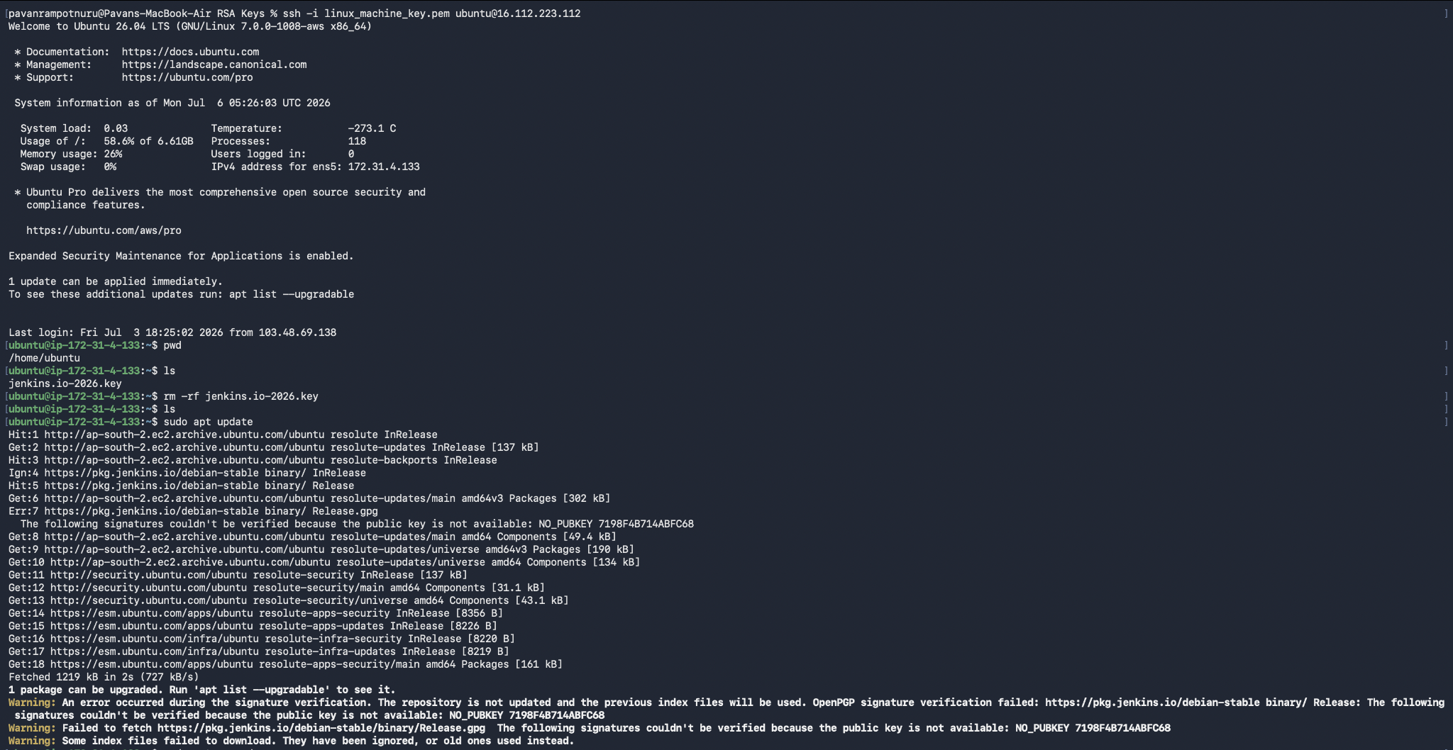
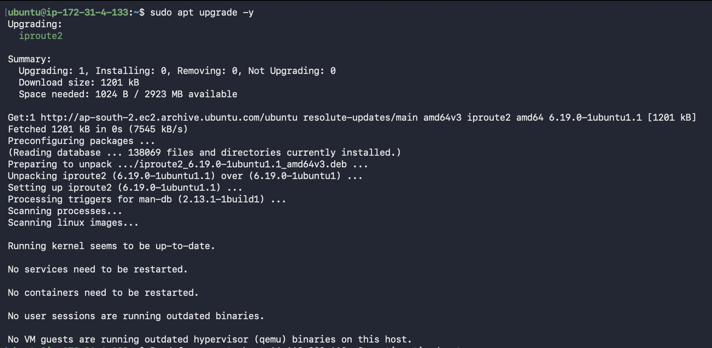
- Install and configure nginx
  - sudo apt install nginx -y
- The default port for nginx is 80. It can be found in the path mentioned below
  - sudo nano /etc/nginx/sites-available/default
- Modify the port to 81 and save the file. Insert the text ‘NgInx is listening to the Port 81’ in the index.html file by using the below command
  - echo "<h1>NgInx is listening to the Port 81</h1>" | sudo tee /var/www/html/index.html
- Once the port is modified, restart the nginx service
  - sudo nginx -t
  - sudo systemctl restart nginx
  - sudo systemctl enable nginx
- Verify it using the command below
  - curl http://localhost:81
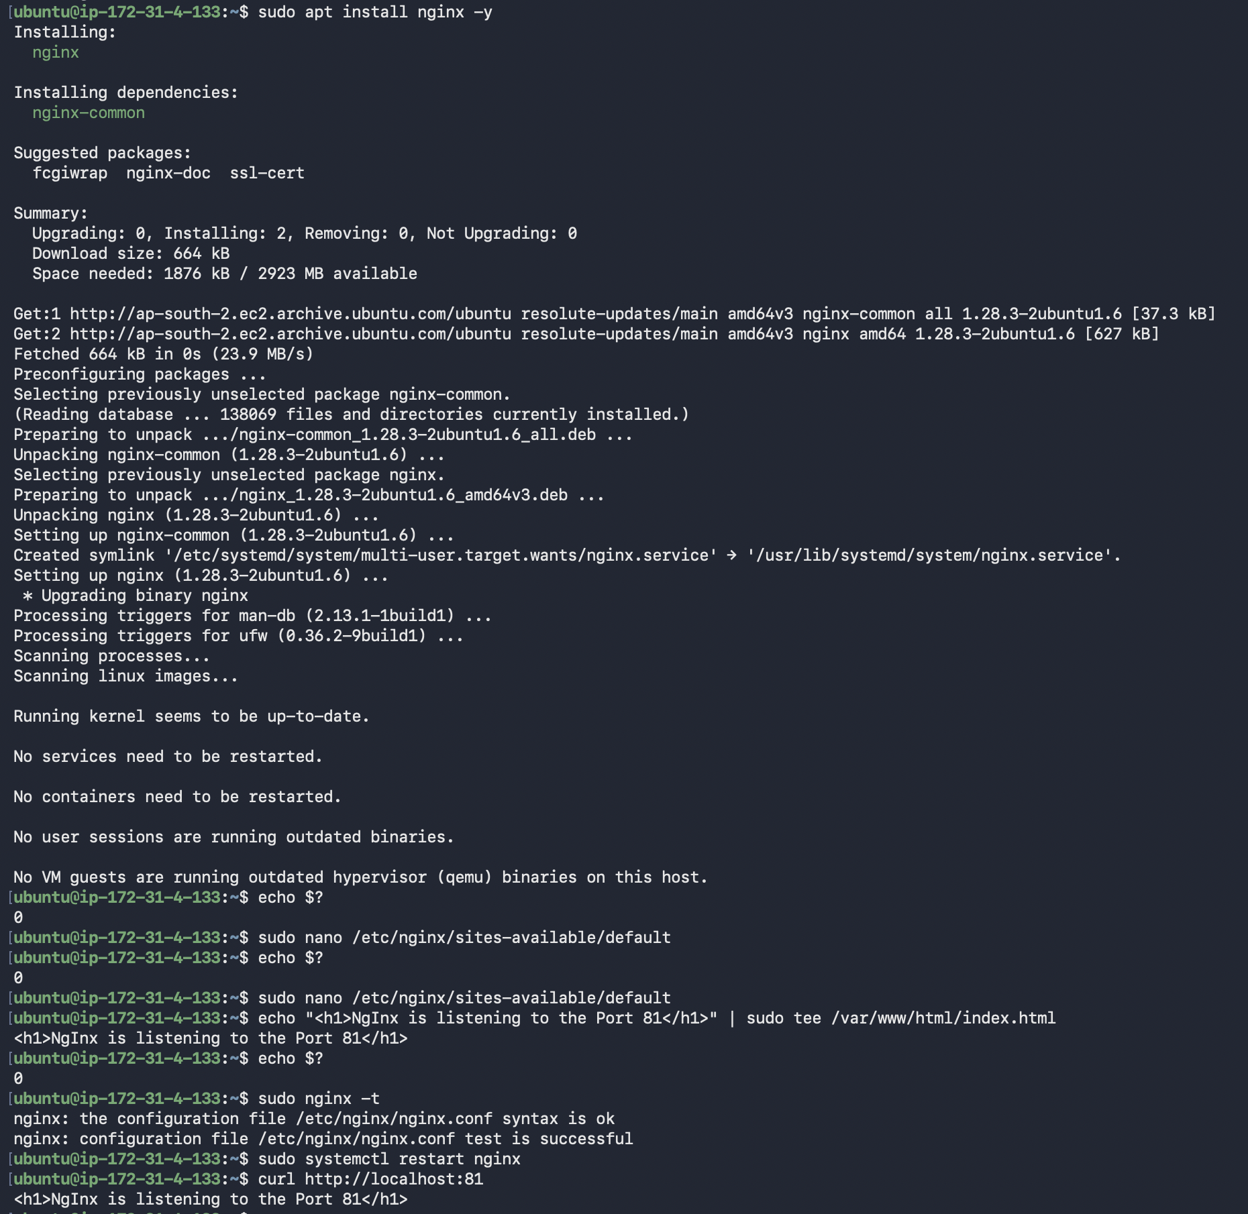
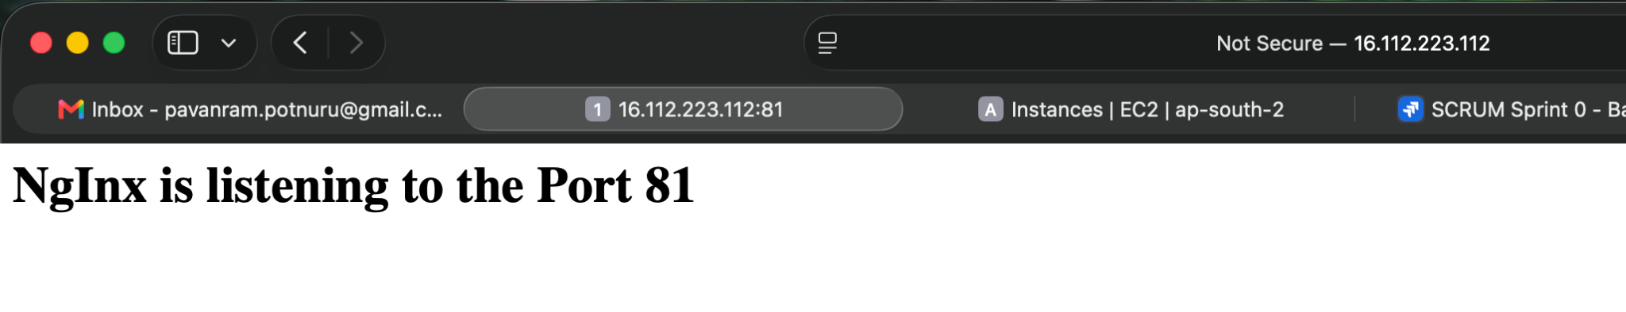
Install Apache on Port 82:-
- Install and configure Apache HTTP server
  - sudo apt install apache2 -y
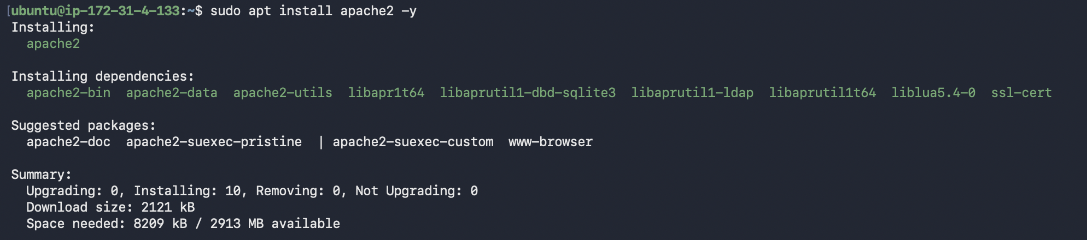
- The default port for apache is 80. It can be found in the path mentioned below
  - sudo nano /etc/apache2/ports.conf
- Modify the port to 82 and save the file. Insert the text ‘Apache is running on the Port 82’ in the index.html file by using the below command
  - echo "<h1>Apache is running on the Port 82</h1>" | sudo tee /var/www/html/index.html
- Restart the apache web server
  - sudo apachectl configtest
  - sudo systemctl restart apache2
  - sudo systemctl enable apache2
- Verify it using the command below
  - curl http://localhost:82
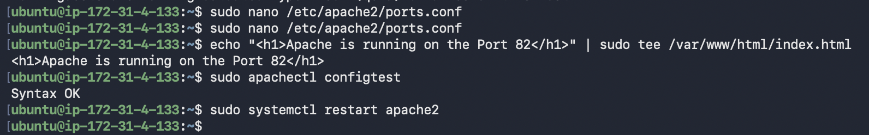
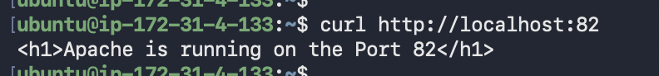
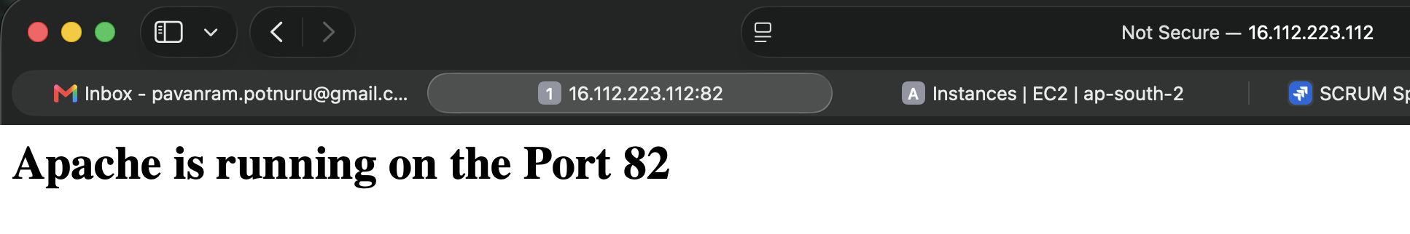

Install Tomcat on Port 8082:-
- Apache Tomcat requires Java Runtime Environment.
  - sudo apt install openjdk-21-jdk -y
- Verify it with
  - java –version
- Create Tomcat User, this ensures a dedicated user account for Tomcat and enhances security.
  - sudo useradd -m -U -d /opt/tomcat -s /bin/false tomcat
- Download Tomcat
  - cd /tmp
  - wget https://downloads.apache.org/tomcat/tomcat-11/v11.0.22/bin/apache-tomcat-11.0.22.tar.gz
- Extract Tomcat
  - sudo mkdir -p /opt/tomcat
  - sudo tar -xzf apache-tomcat-11.0.22.tar.gz -C /opt/tomcat --strip-components=1
- Configure permissions
  - sudo chown -R tomcat:tomcat /opt/tomcat
  - sudo chmod +x /opt/tomcat/bin/*.sh
- Configure Tomcat Port in the below file path, this avoids conflict with other services and runs Tomcat on a dedicated application port.
  - sudo nano /opt/tomcat/conf/server.xml
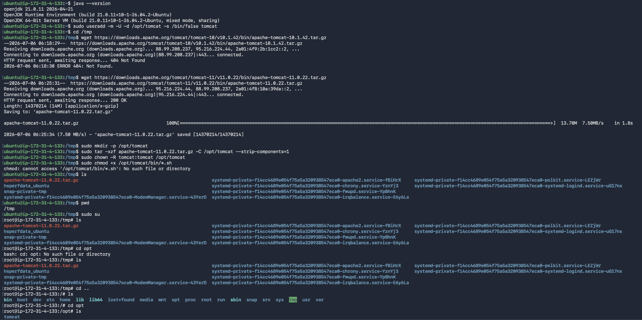
Deploy sample application:-
- Create an application folder,
  - sudo mkdir -p /opt/tomcat/webapps/sample
- Create an index page,
  - echo "<h1>Tomcat Sample Application</h1>" | sudo tee /opt/tomcat/webapps/sample/index.html
- Application url
  - http://SERVER_IP:8082/sample

Create Tomcat Systemd Service:-
- Create a system file using the below configuration
  - sudo nano /etc/systemd/system/tomcat.service
  - [Unit]
Description=Apache Tomcat
After=network.target

[Service]
Type=forking

User=tomcat
Group=tomcat

Environment="JAVA_HOME=/usr/lib/jvm/java-21-openjdk-amd64"
Environment="CATALINA_PID=/opt/tomcat/temp/tomcat.pid"

ExecStart=/opt/tomcat/bin/startup.sh
ExecStop=/opt/tomcat/bin/shutdown.sh

Restart=on-failure

[Install]
WantedBy=multi-user.target
- Reload systemd
  - sudo systemctl daemon-reload
- Enable and start the service
  - sudo systemctl enable tomcat
  - sudo systemctl start tomcat
- Verify it using,
  - sudo systemctl status tomcat
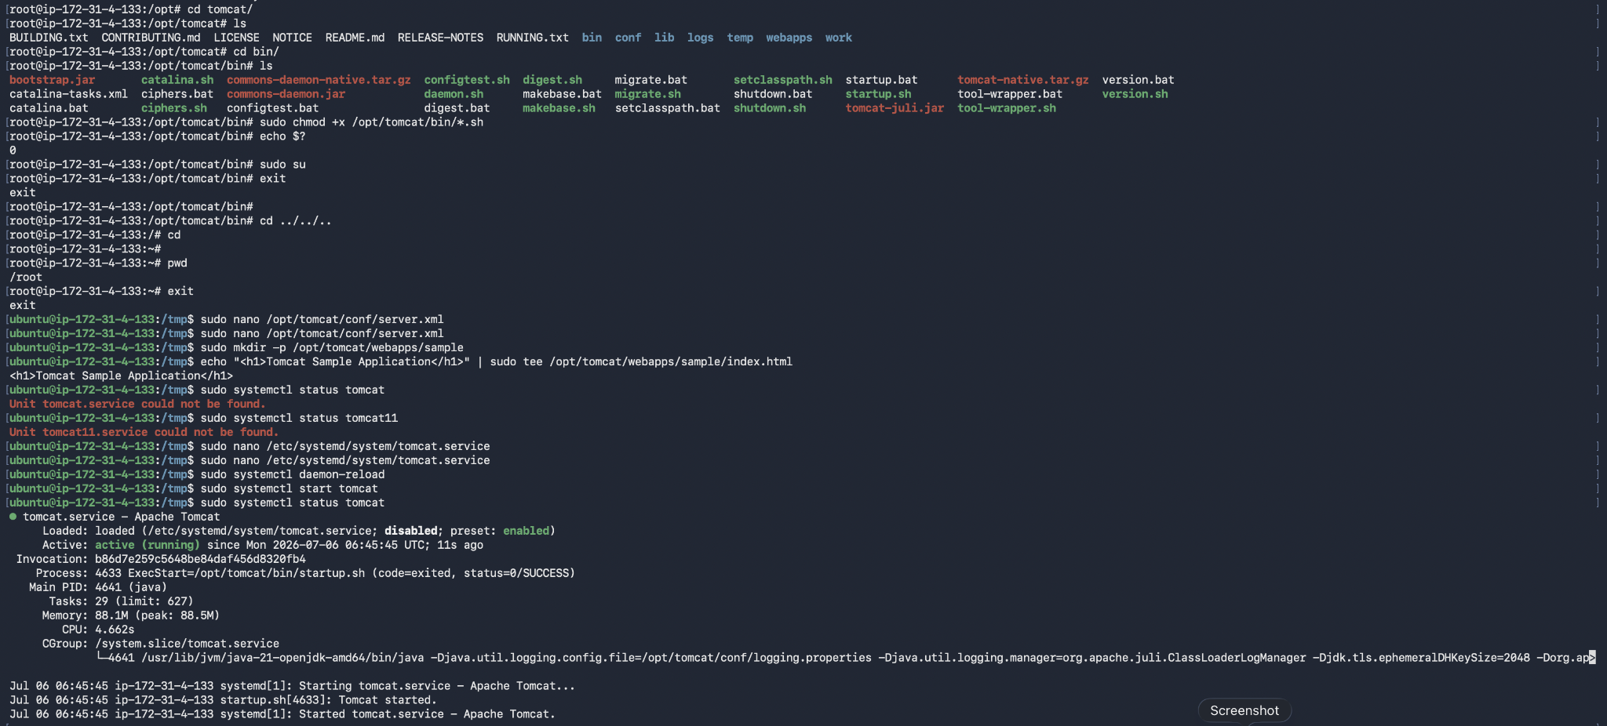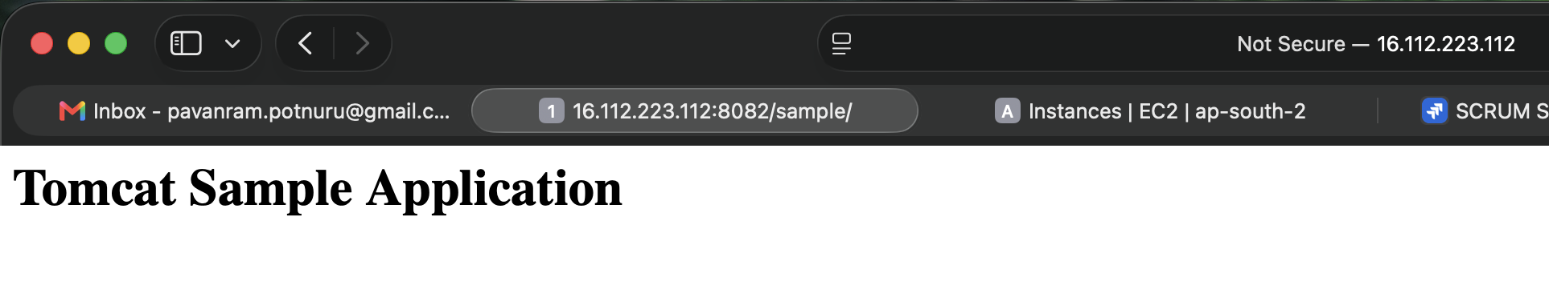
Install and Configure HAProxy:-
- Installation and Backup Configuration
  - sudo apt install haproxy -y
  - sudo cp /etc/haproxy/haproxy.cfg /etc/haproxy/haproxy.cfg.bak
- Append the below configuration to file given below
  - file path: sudo nano /etc/haproxy/haproxy.cfg
  - Config:
frontend web_front
bind *:80
default_backend web_back

backend web_back
balance roundrobin

server nginx 127.0.0.1:81 check
server apache 127.0.0.1:82 check
- To Validate the config file
  - sudo haproxy -c -f /etc/haproxy/haproxy.cfg
  - echo $? - Should get ‘0’.
- Restart the Proxy Service
  - sudo systemctl restart haproxy
  - sudo systemctl enable haproxy
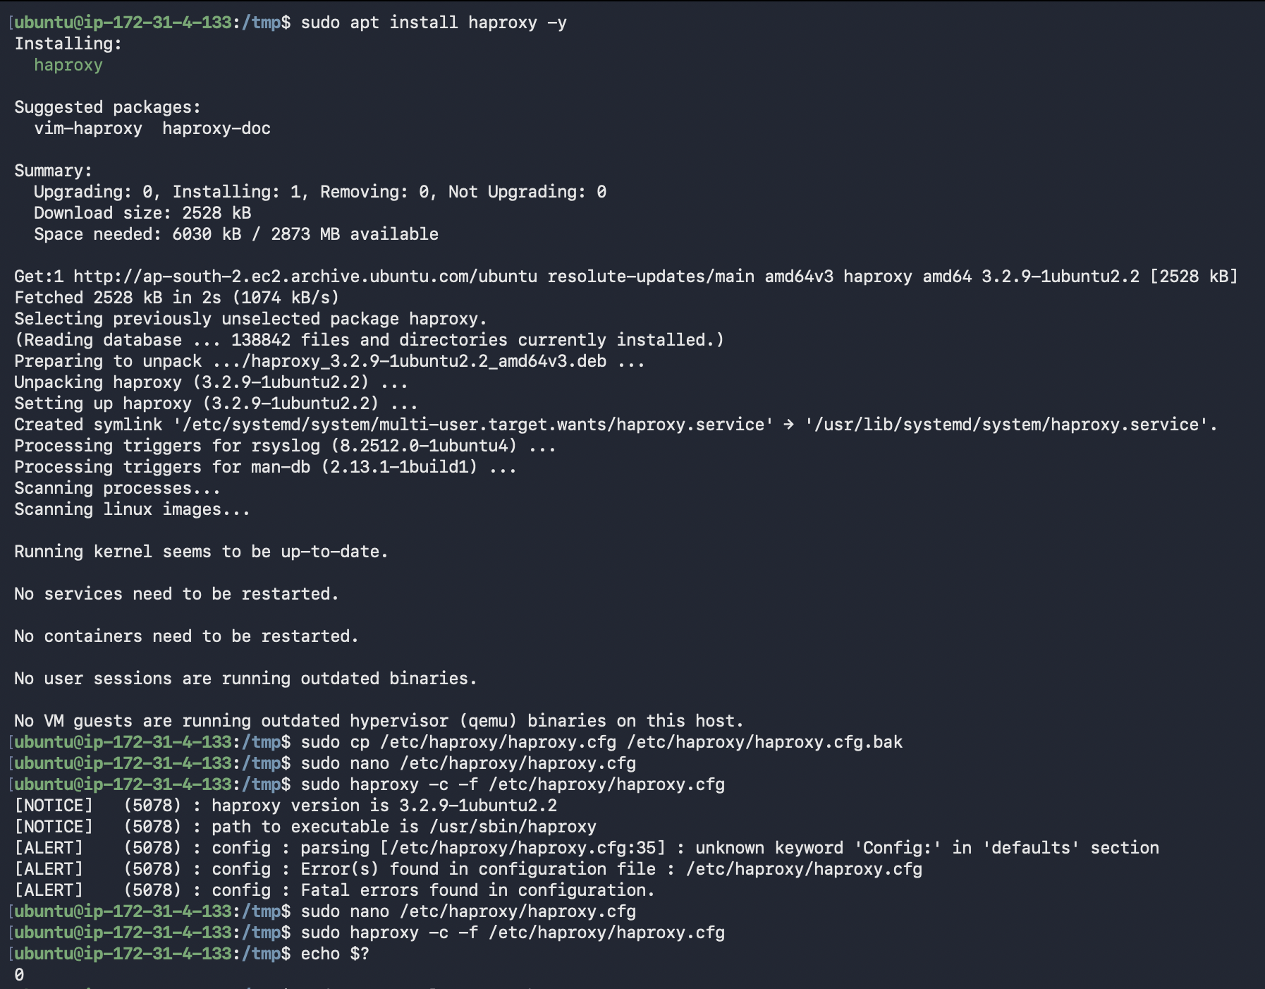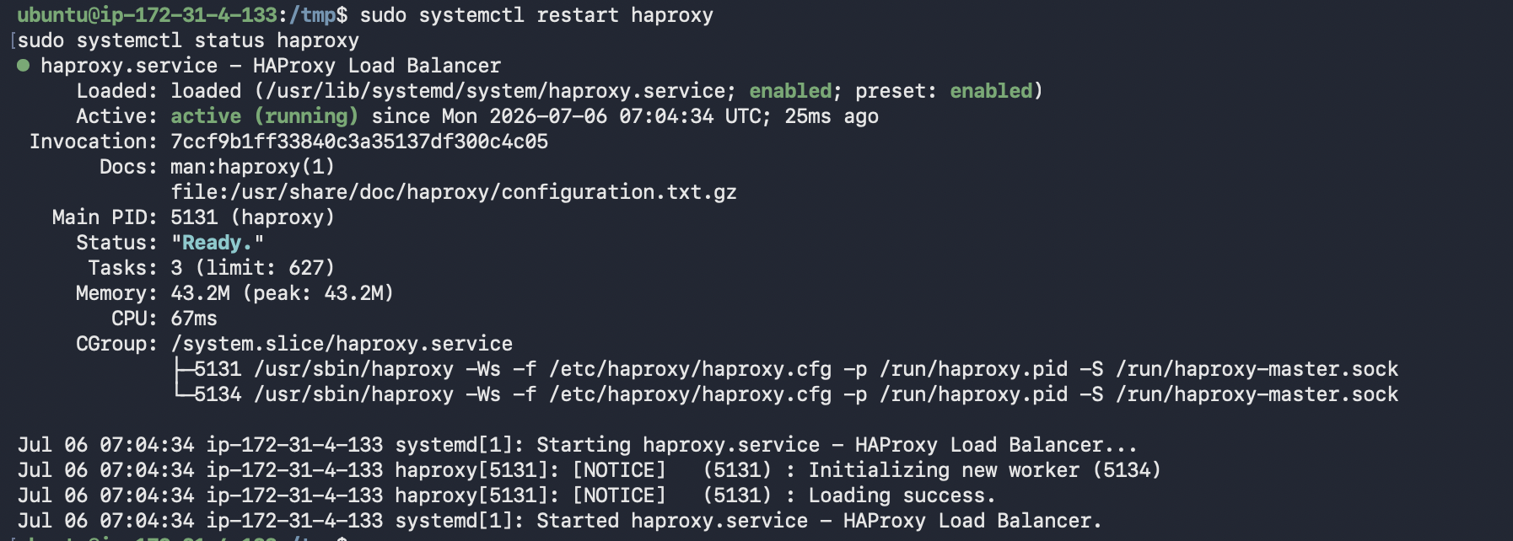

Configure the AWS Security Group:-
- Configuring the inbound rules to allow the traffic and access all the mentioned ports above is a necessary step.
- Head to Security Groups -> Inbound Rules and modify or create a rule with the following configuration. This will allow all the ports mentioned above while configuring multiple web and app servers.
  - 80 - 85 -> Custom TCP - TCP - 0.0.0.0/0 - For HA Proxy, Nginx, Apache
  - 8080 - 8085 -> Custom TCP - TCP - 0.0.0.0/0 - For Apache Tomcat
- To verify all the listening ports
  - sudo ss -tulpn
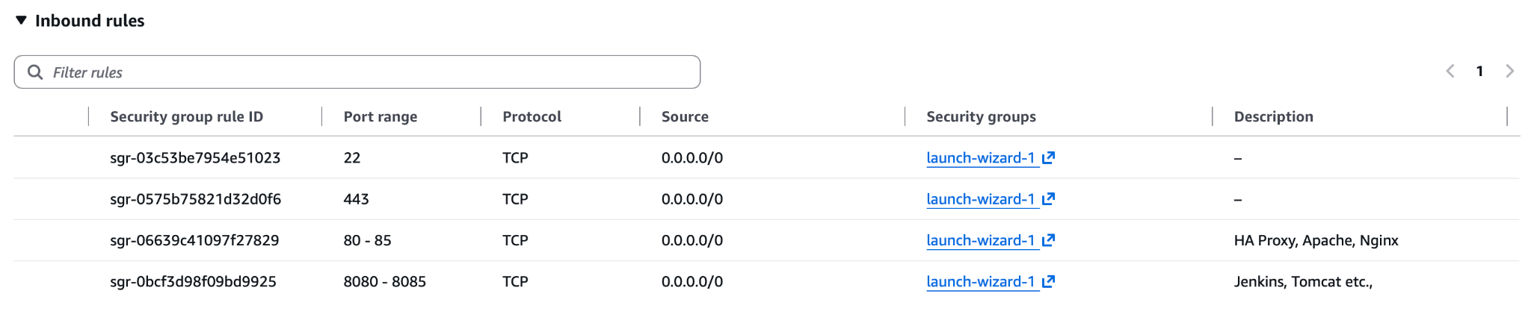

Conclusion:-

Successfully installed and configured Nginx, Apache HTTP Server, Apache Tomcat, and HAProxy on a single Ubuntu EC2 instance. Each service was configured to run on a dedicated port, sample applications were deployed, Tomcat was configured as a systemd service, and HAProxy was configured to distribute traffic between the web servers using Round Robin load balancing.

